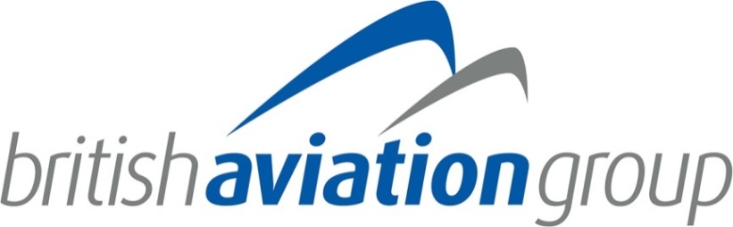
Application for Membership

Membership of BAG is open to any company based and registered in, and conducting business in the UK, with an interest in the aviation sector. In addition, UK registered subsidiaries of foreign owned companies that currently conduct aviation business within and from the UK are also eligible for membership.
Please complete the application form in full to confirm that your company wishes to join the British Aviation Group. Your application will be sent to the BAG membership committee for review and approval. You may be asked to provide additional information if clarification is required.

- Company Details

Company Name
Contact Name & Position
UK Registered Address
UK Primary Correspondence Address (if different from above)
Contact Telephone
Contact Email
Invoice Address (if different to above)
Name of the person the invoice should be sent to
Name of media/ communications contact
Email of media/communications contact
Website
Number of Employees/Owners
Company House Registration Number
Company VAT Number
- Please provide a 100-word profile of your company:

- Please let us know your reasons for joining:

- What are your areas of interest within BAG?

- Is your company an SME? *An SME is defined as a company with fewer than 250 employees and an annual turnover not exceeding €50 million and/or a balance sheet not exceeding €43 million.

Yes ☐ No ☐

- Which of the following markets will your company be focusing on over the next 12 months.
Africa | ☐ | Middle-East | ☐
Asia | ☐ | North & Central America | ☐
Asia-Pacific | ☐ | South America | ☐
Europe | ☐

- Which priority countries will be the focus of your company’s international activities over the next 12 months?

- Which priority countries will be the focus of your company’s international activities over the next 3–5 years?

- Which UK regions do you consider to be your primary centres (s) for your aviation activity?

London | ☐ | North East | ☐
South East | ☐ | Wales | ☐
South West | ☐ | Northern Ireland | ☐
Midlands | ☐ | Scotland | ☐
North West | ☐

- Subscription Rates 2022 - Please indicate your turnover in the aviation business over the past 12 months and state your membership band. Membership rates are based on your company’s UK turnover from aviation activities both in the UK and overseas.

Membership Band | Level of Turnover | Subscription Fee (excluding VAT) | Annual Turnover in Aviation Business | Please select your membership band
Affiliate | Affiliate Band – Individual Consultancies (up to 2 staff including owner) | £280 |  | ☐
A | Less than £300k by the UK business and less than £2m globally by the group in aviation | £575 |  | ☐
B | Less than £1.3m by the UK business and less than £5m globally by the group in aviation | £765 |  | ☐
C | £1.3m - £6m | £1,090 |  | ☐
D | £6m - £18m | £1,350 |  | ☐
E | £18m - £33m | £2,315 |  | ☐
F | > £33m | £2,765 |  | ☐

Academic Membership – Please complete as much of the above form as applicable to your institution

Membership Band | Level of Turnover | Subscription Fee (excluding VAT) | Annual Turnover in Aviation Business | Please select your membership band
Academic Base Band | Less than £300k by the UK business and less than £2m globally by the group in aviation | £575 |  | ☐
Enhanced Academic Membership Band | Over £300k by the UK business and over £2m globally by the group in aviation | £765 |  | ☐

Academic Base Band – applicable to academic members with purely academic activity, i.e. primarily in teaching
Enhanced Academic Membership Band – applicable to academic members whose material business is associated with aviation generating commercial revenue through training or other funded research at turnover levels indicated above

Please note:
- You will be invoiced for subscription payment once the application has been approved by the Membership Committee.
- Your membership will run from January to December.
- Where required, companies may be asked to submit additional information prior to a decision on BAG eligibility is granted

Signed: Date:

Please return this form to Louise Hector, Assistant to Director, British Aviation Group, Salamanca Square, 9 Albert Embankment, London, SE1 7SP. Please email louise.hector@britishaviationgroup.co.uk

Data Protection Act:
The information from your application will be retained by BAG/ADS for internal use.
Information contained in this form can be forwarded to the BAG Membership Committee and other necessary Boards, other relevant organisations if and when deemed appropriate by BAG either in hard copy format or electronically. The details of the Company’s products, services and contacts may be made available through the BAG Directory and similar media and therefore may be reviewed by customers.

Tick here if you do not wish to be kept informed about other relevant BAG events.

Tick here if you do not wish to receive information from other companies that have been approved by us.

BAG is a trade organisation facilitated by ADS, a company limited by guarantee. As such, the extent of a Member’s liability cannot exceed £100 which they are asked to guarantee.

